**TOPIC- Intelligent Vehicle Parking**

END TERM REPORT

***by***

**NAME OF THE CANDIDATE(S)**

|  |  |  |
| --- | --- | --- |
| NAME | REG NO. | ROLL NO. |
| Rishav kumar | 11810275 | 33 |
| Himansh Nagar | 11804854 | 50 |

**GitHub Link:** <https://github.com/Rishav7079/rishavAIproject>



**Department of Intelligent Systems**

**School of Computer Science Engineering**

**Lovely Professional University, Jalandhar**

**Student Declaration**

This is to declare that this report has been written by me/us. No part of the report is copied from other sources. All information included from other sources have been duly acknowledged. I/We aver that if any part of the report is found to be copied, I/we are shall take full responsibility for it.

|  |  |
| --- | --- |
| **Roll no.** | **Name** |
| 33 | Rishav kumar |
| 50 | Himansh Nagar |

**TABLE OF CONTENTS**

**TITLE PAGE NO.**

**1. Background and objectives of project assigned**

**Background and objectives of the project-**

Intelligent Parking Service is a part of Intelligent Parking Systems . The searching of parking burn a lot of barrel of the world oil every day. Car parking problem is a major role in congestion of traffic and has been still a major problem with increasing vehicle size in the luxurious segment and also confine parking spaces in urban cities. The rapid growth in the number of vehicles worldwide is intensifying the problem of the lack of parking space. As the global population continues to urbanize, without a well-planned convenience driven retreat from the car these problems will worsen in many countries. The current unmanaged car parks and transportation facilities make it difficult to accommodate the increasing number of vehicles in a proper, convenient manner so it is necessary to have an efficient and smart parking system. Smart parking management systems are capable of providing extreme level of convenience to the drive. Localization is a key issue of the navigation system to guide unmanned ground vehicle in an intelligent Space. Intelligent Space is an environmental system. This intelligent Space able to support informative and physical ways. The proposed system includes sensors information fusion, position estimation, path planning and tracking. Camera is used to get image information of the robot. Image processing and FPGA embedded together to identify position and orientation of UGV very correctly and accurately. The proposed architecture works on distributed image processing pixels which causes the amount of data to be transmitted through communication network will be minimum.

**Goal and Benefits Analysis of Smart Parking-**

* Optimize parking space usage.
* Help traffic in the city flow more freely.
* Guides residents and visitors to available parking.
* Accurately predict and sense spot/vehicle occupancy in real-time.
* Saving money , time and the stress of searching for vehicle parking.
* Smart parking plays a major role in creating better urban environment by reducing the emission of CO2 and other pollutants.

**Introduction-**

The searching of a parking space in a parking lot in commercial area is a so much frustrating activity for many people. More problem increases with the high growth rate in the registration of new cars worldwide. There are many parking places of modern technologies existing but many drivers don’t know about the parking blocks so this is big challenge for us to acknowledge the people about smart parking which will help to save a lot of fuel and systematizing the parking of vehicles.

To overcome from these problems of congestion of traffic and save the fuels from it, the unique step of solution is smart parking.

• The services which the Intelligent Parking System should provide in the future are-

a. The parking availability information system and parking reservation system should provide advanced navigation services.

b. The mobile electric commerce system and a continuously working gate system should collect the toll charges electrically

c. An automated navigation system should assist in safe driving.

d. An in-facility navigation system should provide the best possible traffic management.

e. Provision of effective security for the safety of cars.

f. Provision of strong functions for facilitating administrators and managers in management of the parking facility.

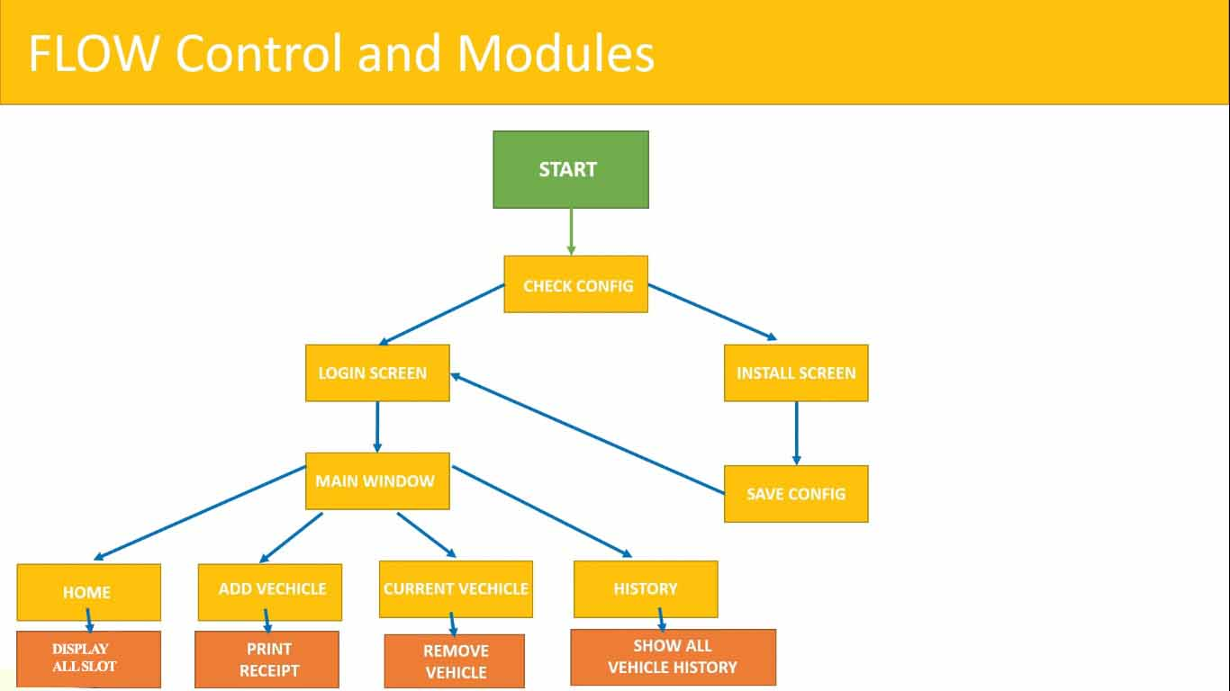

**Login Screen-**

In login screen user required to enter the user-name and password. If user-name and password matches with data base then user promote to HOME WINDOW, else show error message.

LOGIN

PASSWORD

USER-NAME

**Home Window-**

In home window user can see the available places where he can parked vehicle. User has options Add vehicle, Manage vehicle and history.

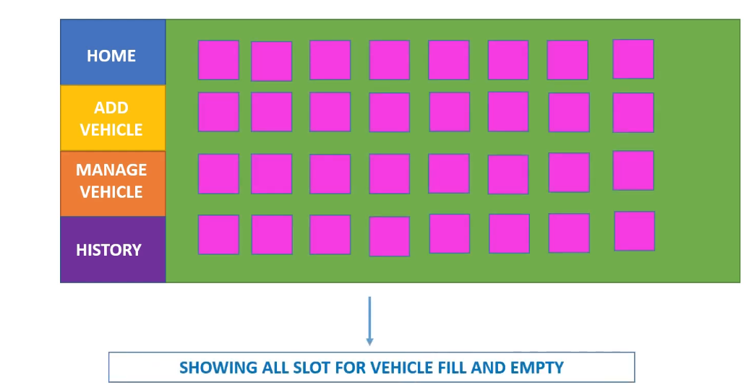

**Add vehicle-**

In this field user have to enter Name, vehicle number and Mobile number.After adding the vehicle successfully user will get receipt.

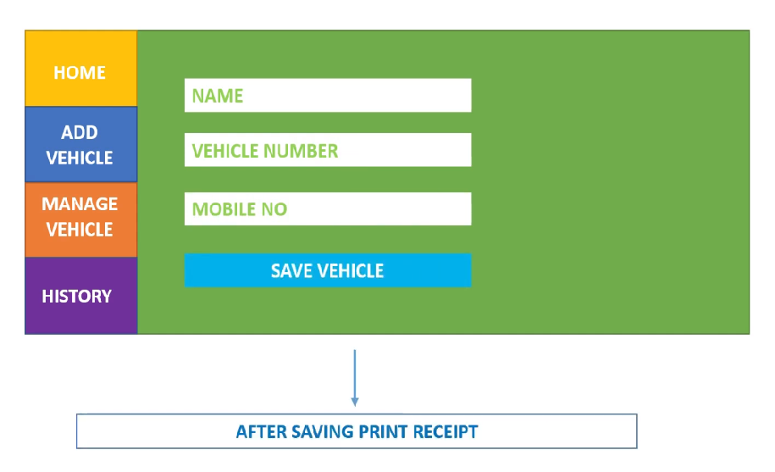

**Manage vehicle-**

In this window user get all data of parked vehicle such as vehicle number, entry time from this window user can take exit action of the vehicle.

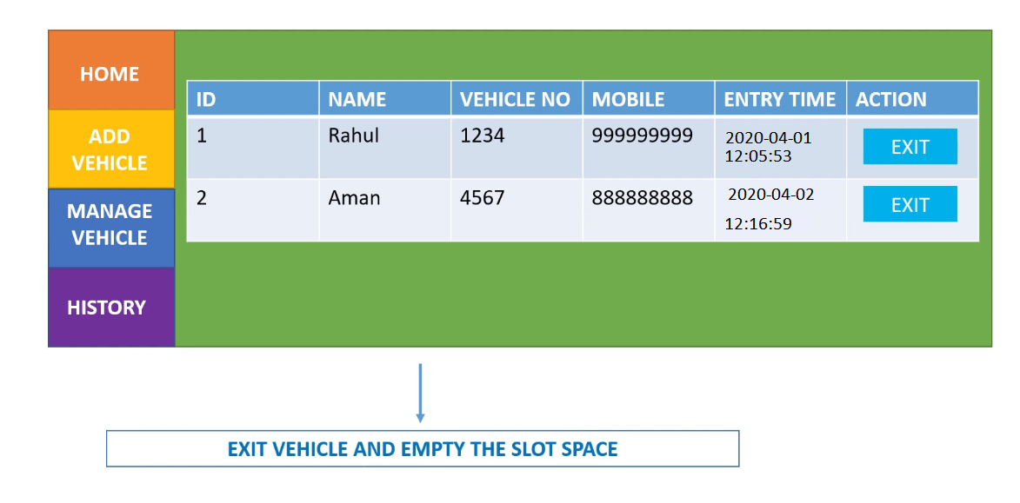

**History-**

In this module use can see the history of vehicles(E.g.- Name, vehicle number, Mobile number, entry time and exit time).

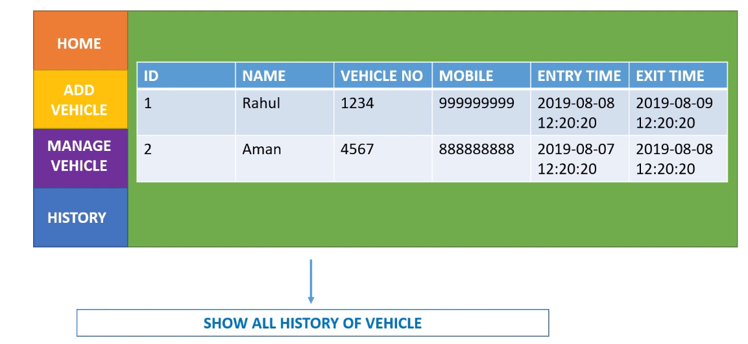

**Work Description by Each Student-**

* Reg No-11810275

Role-Implemented the modules of Home Window ie Add vehicle, Manage vehicle. According to empty slot the vehicle will be parked and slots will be properly managed. In add vehicle module Vehicle number, Mobile number of driver will be recorded during time of parking as well as for future scope. In manage vehicle module vehicle will be managed according to entry and exit time and user can take exit from the parking.

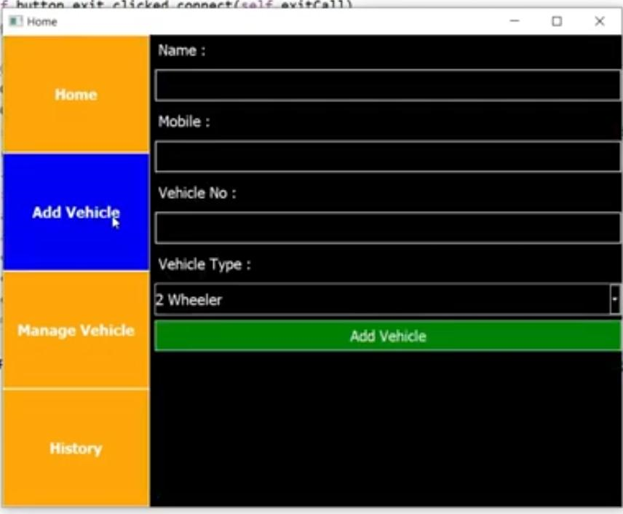

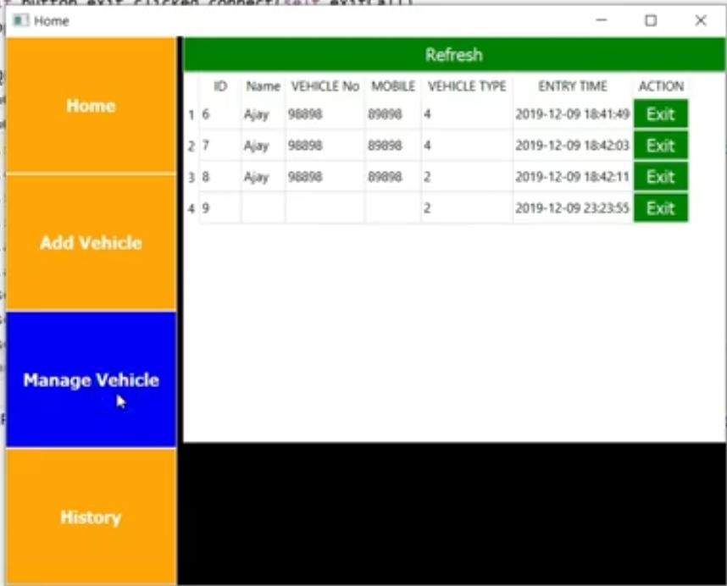

* Reg No-11810275

Role-Implemented all the Data Base Operations and implemented the Home window module ie History. In Data base operations, through MySQL data had been created and used for all the modules of the project. In History module of home window we can see the history of all the vehicles parked ie its vehicle number, entry time, exit time and user’s mobile number. In case of any discrepancy history module will help us to track all the vehicles parked.

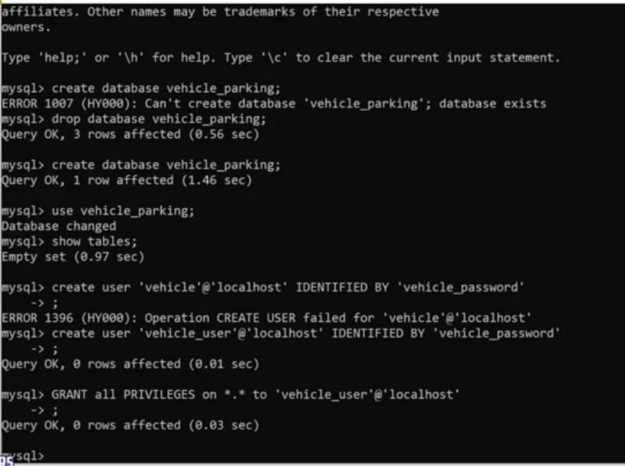

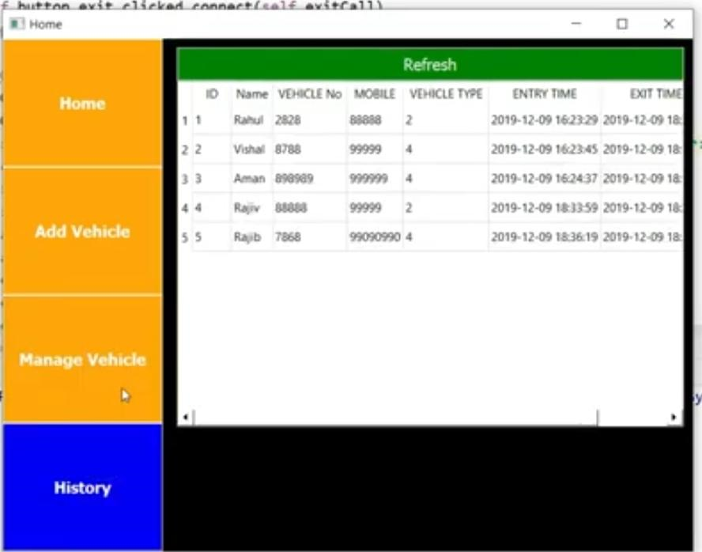

Reg No-11804854

Role-Implemented the Install window and seats allocation in home window. Seats allocation is for how many slots are vacant in parking area and accordingly we can park the vehicles. Install window is for Installation purpose of all the modules properly. Slots allocation in parking area is essential to enquire about the parking can be done further or not and also the capacity of parking area.

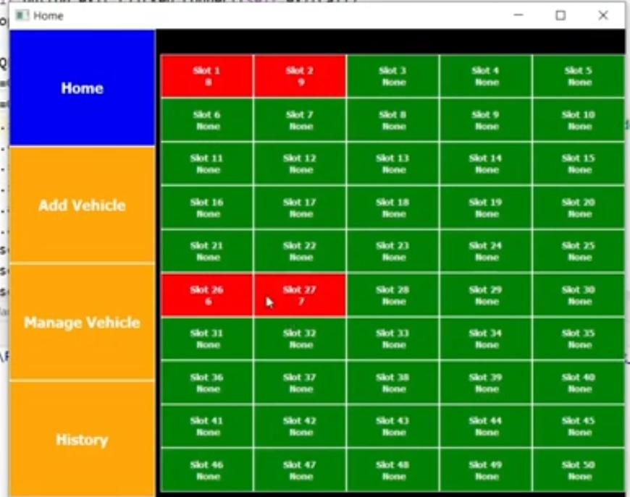

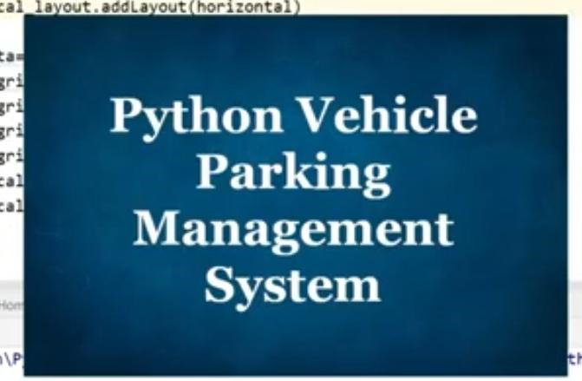

Reg No-11804854

Role-Implemented the log in screen of Login window. Here privacy of admin will be checked whether he is eligible or not for doing so.Here he have to enter user name and password assigned and if the credentials are correct then he can proceed to home window otherwise it will show error. Also implemented the main program where integration of all module is done and linking part is also there.

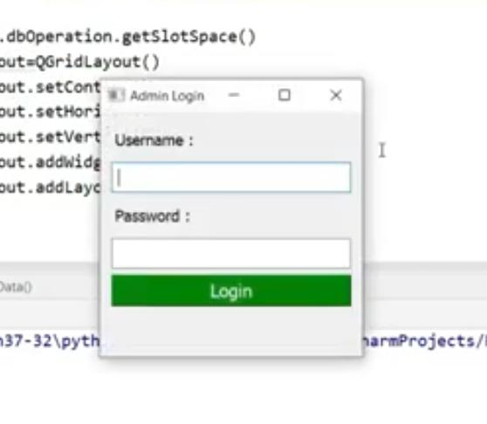

**Technologies and framework to be used-**

* Smart Parking System
* Android App
* Sensing Camera
* M2M Services Innovation
* Parking Zone

**Different Technologies**

Features Services Provided -

1. Agent Based

Dynamic Distribution and Complex Traffic Environments

Bargaining, parking guidance and route negotiation etc.

2. Fuzzy Based Human-like intelligence and expertise

Intelligent parking methods e.g. parallel parking and perpendicular parking etc.

3. Wireless Sensor Based

Low cost implementation with lower power consumption

Detection and monitoring of the parking facility etc.

4. GPS Based

Real time location based information and guidance towards destination

Provides information about the locality and availability of parking facility

5. Vehicular Communication

Provision of parking information distribution service for mobile vehicles

Antitheft protection, real time parking navigation service etc.

6. Vision Based

Good for car searching in large parking lots

Lot occupancy detection, parking space recognition, parking charges collection etc.

**SWOT analysis-**

In this project we have discussed the methods that can be adopted for intelligent parking system . These systems can counter the parking problems that arise due to the unavailability of a reliable, efficient and modern Parking system. Such parking system can reduce the parking related issues. Such system can help the economic, social and safety based aspects of the society. It also helps in preserving the environment, fuel and time.

The economic analysis can help us find the feasible project so that we can have a better parking system without making the economy suffer. Future work should be done for integrating different technologies together in order to achieve a system which is the most efficient, reliable, secure and inexpensive. The economic analysis should be done both quantitatively and qualitatively. After the economic analysis is done, then the project can be ameliorated.

A simulation of this system is implemented to understand the working of the diﬀerent type of services such as the parking spot ﬁnder, allocation of parked vehicle spots, and locating the parked vehicle. The system is designed to simulate diﬀerent parking slots across diﬀerent building for a particular city. This system is intended to allot a single parking slot for a user (vehicle) on the entry of user into the parking bay and provide user with the unique parked vehicle identiﬁcation number to locate the parked vehicle later. The system maintains at the repository level, the available free slots in a particular ﬂoor, the allotting slots, and the slots that are reserved. A reserved slot may mean the parking slot is allotted to a vehicle which has just entered the parking bay, but has not occupied that particular slot, at the current time instance; it can also mean that the slot is reserved for a particular user or vehicle which has not yet entered the system currently.

The system records the empty slots, reserved slots and available slots for every instance of time when a vehicle enters or exits the parking bay. The system also keeps track of all the vehicles that are parked and those that are not parked in the parking bay, thus also helping for the purpose of vehicle tracking. This would facilitate in prevention of theft and misuse of vehicles .

The system also plans to output the current position of the vehicle . This could be helpful in vehicular tracking in and around the city. The main achievements of the simulation of the system include addressing the unavailability of an integrated vehicle parking service on a city-wide basis, and locating a parked vehicle only by its respective authorized user. A centralized service helpful even in monitoring the vehicle movement in and around the parking bays and the city as well , there by detecting some of the suspicious movement of vehicles in a particular city. This system would also help record current and past statistics of the number of vehicles active in the city to those number of vehicle parked.

Existing systems use the manual generation and allocation of the parking slots to vehicles that enter, or such slots are chosen in a semi-automated manner or by drivers themselves in an unpredictable manner. The new parking system allows for the vehicle to be alloted a designated parking slot while it enters the parking bay based on the sensed OBU present in it. The waiting times of vehicles at the entry of the parking bay at diﬀerent time instances spanning across diﬀerent arrival rates of vehicles. This information could be used by the parking uniformly distribute parking loads on each instance, thereby assigning the parking slots accordingly to vehicles that enter the parking bay. This could also be used to regulate the traﬃc ﬂow of vehicle in and around the parking bay.

**Conclusions**

In this project we have discussed the methods that can be adopted for intelligent parking system . These systems can counter the parking problems that arise due to the unavailability of a reliable, efficient and modern Parking system. Such parking system can reduce the parking related issues. Such system can help the economic, social and safety based aspects of the society. It also helps in preserving the environment, fuel and time.

The economic analysis can help us find the feasible project so that we can have a better parking system without making the economy suffer. Future work should be done for integrating different technologies together in order to achieve a system which is the most efficient, reliable, secure and inexpensive. The economic analysis should be done both quantitatively and qualitatively. After the economic analysis is done, then the project can be ameliorated.